Principles and Elements of Art

Elements Principles

Line | Rhythm
Shape | Movement
Form | Balance
Space | Proportion
Colour | Pattern
Value | Emphasis
Texture | Unity

Elements of art:
- The building blocks of visual art

Principles of art:
- use or arrangement of the building blocks of visual art

Composition:
- the organization of the elements of art according to the principles of art.

Elements of Art
Line
- the path of a point moving through space

Shape
- A two-dimensional area that is defined in some way

Form
- Objects having three dimensions (height, width, depth)
- Ex. Cubes, cylinders, spheres

Space
- Space refers to the area in which art is organized. Perspective is representing a volume of space or a 3-dimensional object on a flat surface.
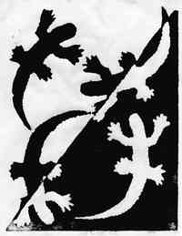

Colour
- Colours all come from the three primaries and black and white. They have three properties – hue, value, and intensity.
Value
- Value refers to relative lightness and darkness and is perceived in terms of varying levels of contrast


Texture
- Texture refers to the tactile qualities of a surface (actual) or to the visual representation of such surface qualities (implied).


Principles of Design
Rhythm
- Indicates movement by a repetition of elements
- 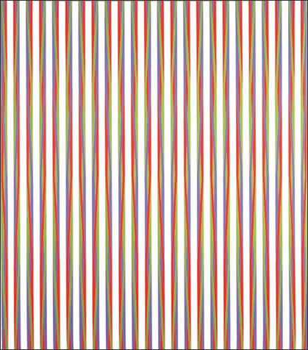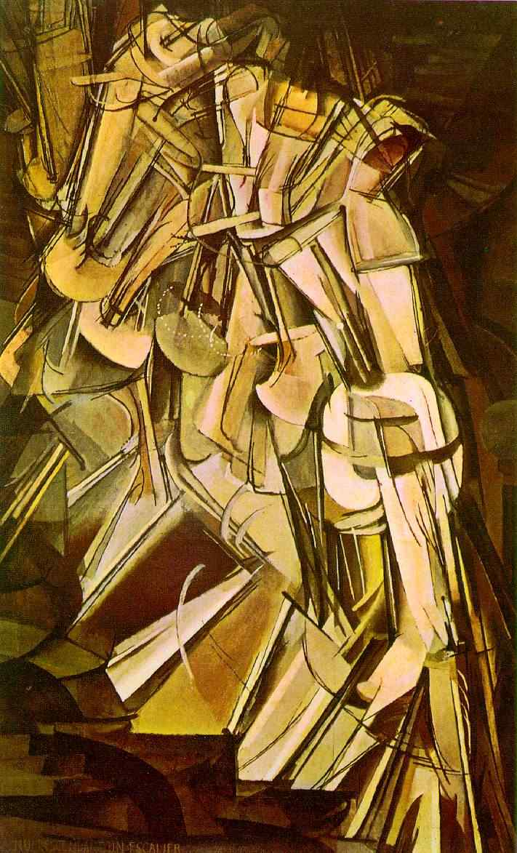
Movement
- Used to create the look and feeling of action and to guide the viewer’s eyes throughout the artwork
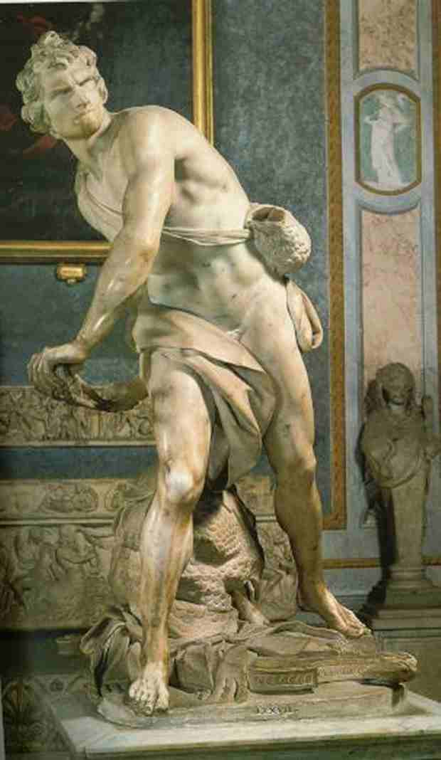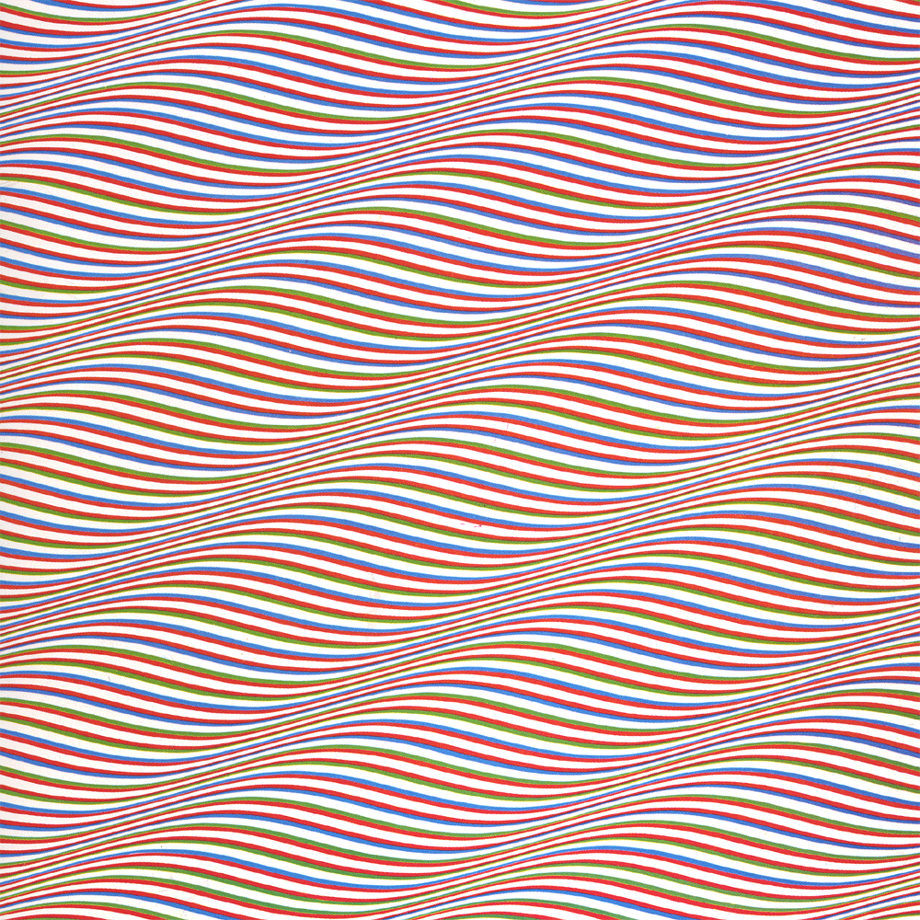

Balance
- Concerned with equalizing visual forces, or elements, in a work of art.

- Formal or Symmetrical:
- Elements are equally distributed in mirror image
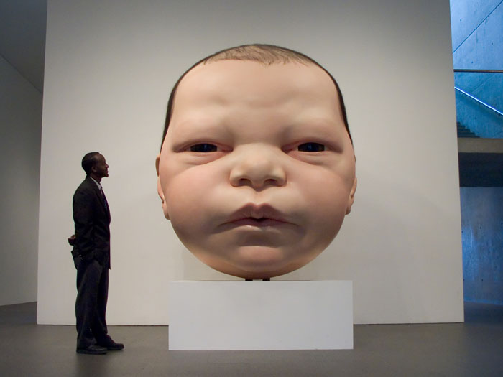

- Informal or Asymmetrical:
- Balance is visual; a more dynamic and interesting arrangement. Weight is usually distributed unevenly throughout the piece.

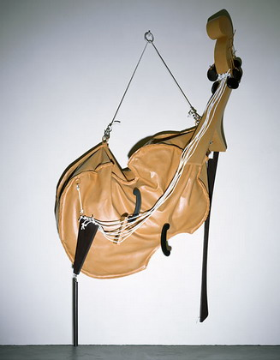
- Radial:
- Elements radiate from a central point
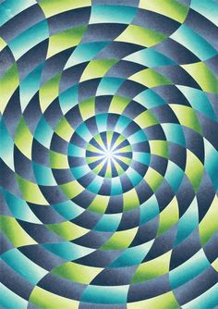
Proportion
- Proportion is the size relationship of parts to a whole and to one another.
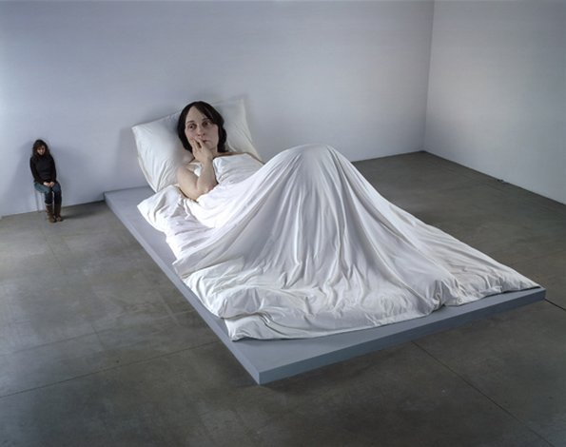

Pattern
- Pattern refers to the repetition or reoccurrence of a design element, exact or varied, which establishes a visual beat.
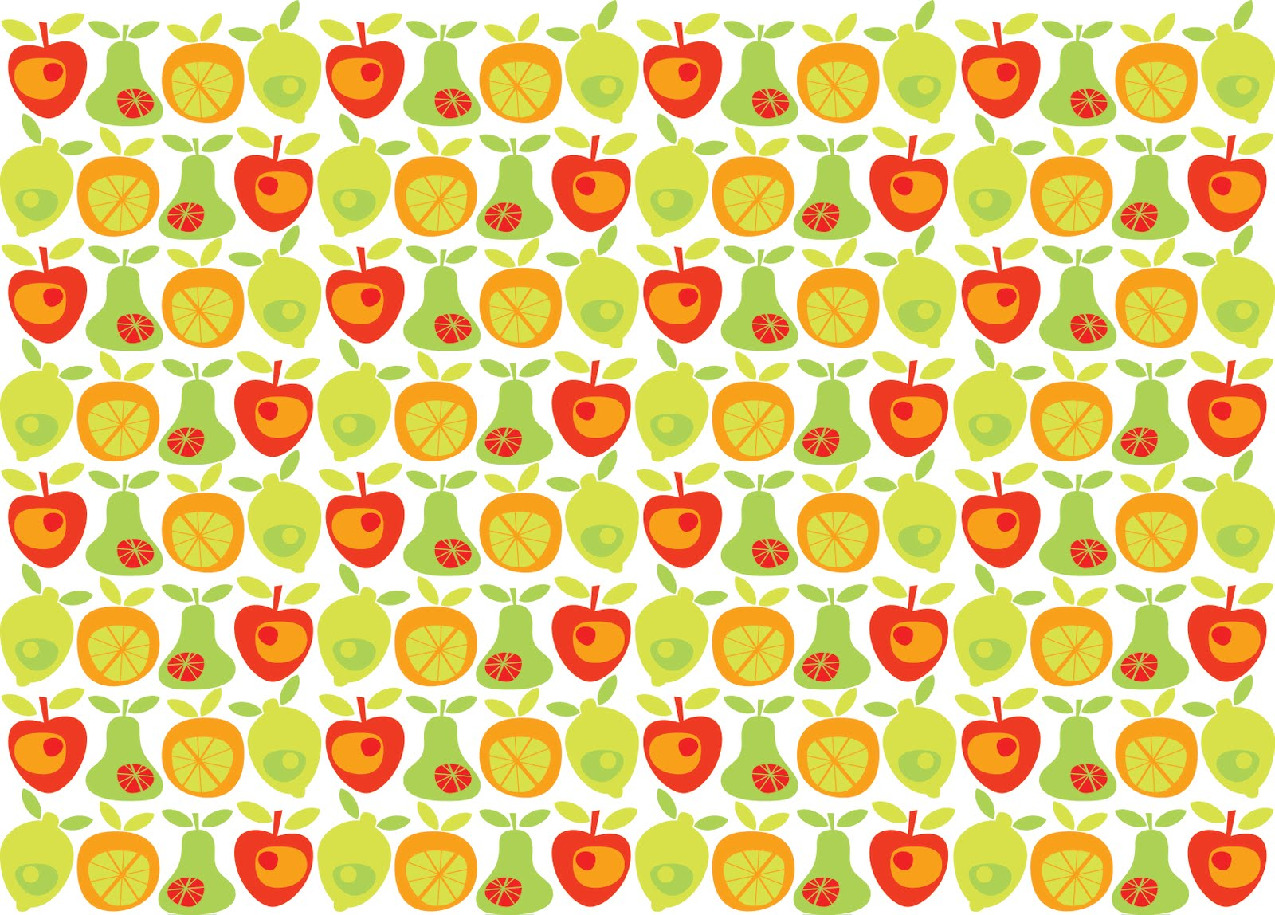

Emphasis
- Makes one part of the work more dominant than the other parts
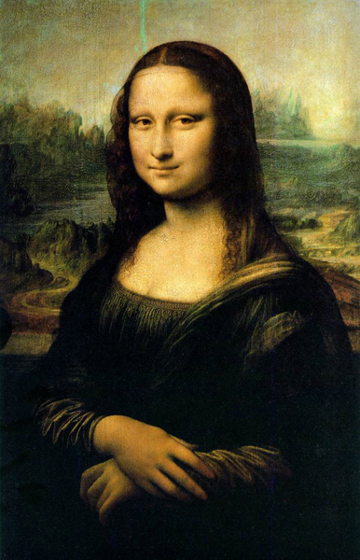
Unity
- Unity is achieved when the components of a work of art are perceived as harmonious, giving the work a sense of completion.

